**CSE334:** Software Engineering

**Major task report**

**RedPlus**

# Software Requirement Specification (SRS)

## Introduction

A web based blood bank management system. Patients and medical expert have to register through entering their information, they can donate and request blood after logging in to their accounts. While the request process they must enter the blood type they want to receive. Medical expert have to give his approval according to blood types of the donators and receivers, as well as requesting and donating. A notification is send to the receivers when his request is approved. Medical expert can transfer the non-matching donors and receivers to the facility where they can donate and receive blood.

## Feasibility analysis

## System requirements

### Functional requirements

1. Patient and medical expert must register by entering their full name, email, phone number, password, diseases, location, role (user or expert) and blood type.
2. User and expert should be able to login after registration by entering their phone number and password entered while registration.
3. User must login to be able to donate and request blood as well as the medical expert.
4. User and medical expert can request blood by entering full name, phone number and blood type (if he want to request for another patient in operation or surgery )
5. User can donate to facility by selecting the facility name from the list as well as people by choosing one of the donating cards available to donate.
6. Donating cards appear according to nearest location and blood type.
7. Donating cards take green color when it is eligible to donate while it take white card when it is not eligible to donate.
8. Donating card doesn’t show any contact information for the default user about the receiver except blood type. Contact information appear only to the expert for privacy.
9. Medical expert approve pending blood transaction or transfer it to facility.
10. If their request still pending without donation eligible for it the medical expert has to transfer it to facility.

## Non- functional requirements

1. The system must be available 24/7 with no bandwidth issues.
2. System should not register user unless creating strong password more than 4 characters.
3. Runtime of page is less than one second.
4. Extendable website in case there is new functional requirements need to be added.
5. If issues happened in the system then it must be programmed in way that developer can serve it again.
6. The system should be available for using in the whole city not a certain area.
7. Implementation required for front- end is React framework with Redux library, back-end Node.js and database MongoDB (noSQL database).

## Requirements validation

### Source traceability matrix

|  |  |  |  |  |
| --- | --- | --- | --- | --- |
|  | Patient | Facility | Medical expert | Developer |
| 1 |  |  | **Checkmark with solid fill** |  |
| 2 |  |  |  |  |
| 3 |  |  |  |  |
| 4 |  |  |  |  |
| 5 |  |  |  |  |
| 6 |  |  |  |  |
| 7 |  |  |  |  |
| 8 |  |  |  |  |
| 9 |  |  |  |  |
| 10 |  |  |  |  |
| 11 |  |  |  |  |
| 12 |  |  |  |  |
| 13 |  |  |  |  |
| 14 |  |  |  |  |
| 15 |  |  |  |  |
| 16 |  |  |  |  |
| 17 |  |  |  |  |

### Requirement traceability matrix

|  |  |  |  |  |  |  |  |  |  |  |
| --- | --- | --- | --- | --- | --- | --- | --- | --- | --- | --- |
|  | 1 | 2 | 3 | 4 | 5 | 6 | 7 | 8 | 9 | 10 |
| 1 |  | R |  |  |  |  |  |  |  |  |
| 2 | D |  |  |  |  |  |  |  |  |  |
| 3 | R | D |  | D | D |  |  |  |  |  |
| 4 | R | R |  |  |  |  |  |  | D | D |
| 5 |  |  |  |  |  | D | D |  |  |  |
| 6 |  |  |  | D | D |  |  |  |  |  |
| 7 |  |  |  | D | D |  |  |  |  |  |
| 8 |  |  |  | R |  |  |  |  | D |  |
| 9 |  |  |  | D | D |  |  |  |  |  |
| 10 |  |  |  | R | D |  |  |  |  |  |

## Time plan

# Analysis and Design document

## Use-Case Diagram and the Swimlane Diagram

### Use - Case diagram

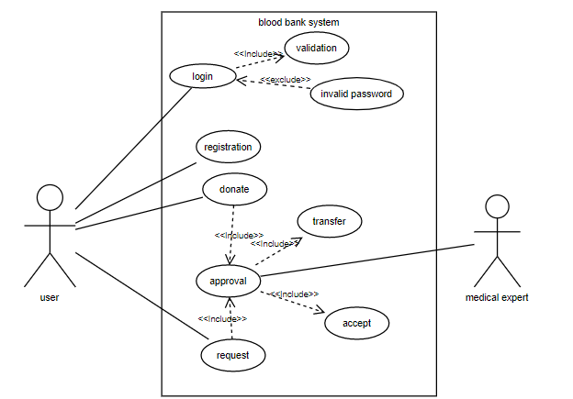

In this use-case diagram User is primary actor, he have to register at first the login to be able to request or donate. while medical expert in this case is secondary actor as he revise pending transactions, in the case of acceptance the transaction will disappear from pending and from the donating cards that appear while donating, in case of transfer the medical expert have to choose one of the listed facility and transfer the request to it.

### Swimlane diagram

## Interaction diagrams

## State diagram

## Data flow diagram

### Context diagram (level 0)

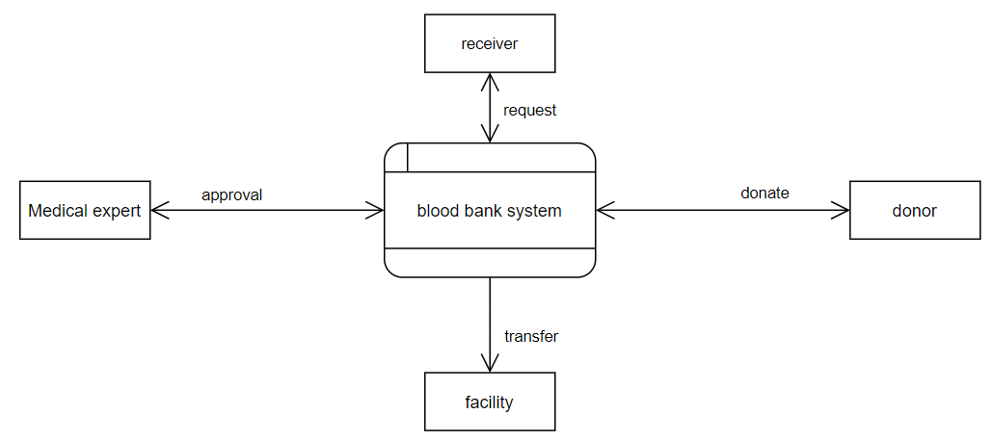

Assuming we have 3 entities Medical expert , user and facility. in case of donating and request there is exchangeable data flow between them and the system. the medical expert approve transactions between donors and receivers. facility receive from the system blood transaction which are not accepted by medical expert.

### Level 1

## System architecture

## Component diagram

## Class diagram

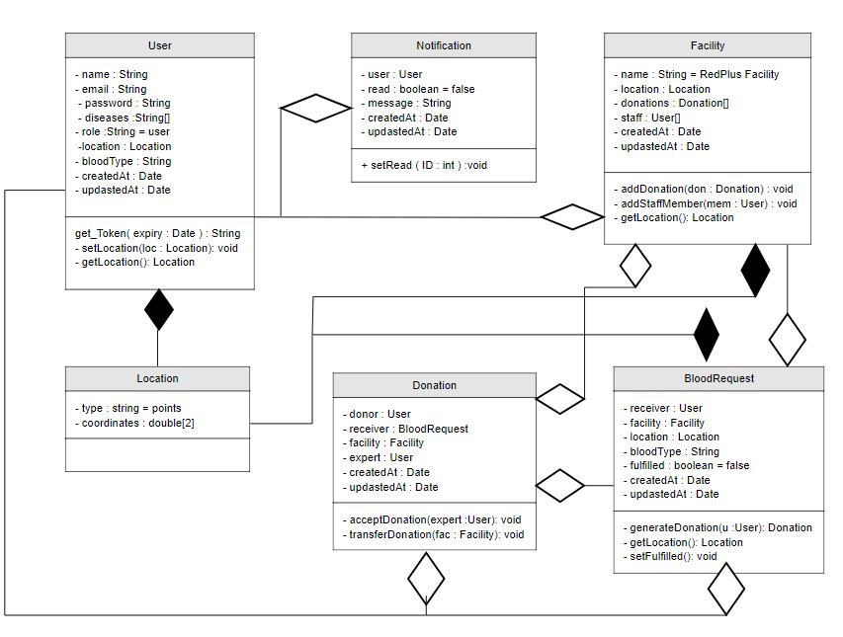

## User interface design

# End-User guide